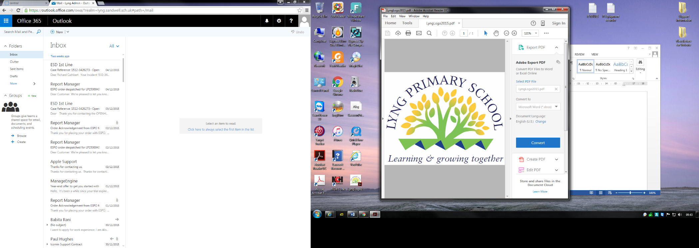

Intimate Care Policy
and
Staff guidance
(Taken from safeguarding Policy 2019)

September 2026

Intimate care policy

Statement of Intent
This policy has been devised to support pupils who enter Lyng primary school and the Early Years who are not toilet trained, as well as pupils who have medical needs or developmental needs that mean pupils are required to wear nappies/training pants or pull-ups.
Lyng Primary School is inclusive and recognises the developmental needs of all pupils, and as such admit children who are not fully toilet trained.
Lyng Primary School teachers & support staff will be responsible for implementing the intimate care of pupils and will follow the Intimate Care Policy guidance. Volunteers or students will not be responsible for carrying out the intimate care of pupils. Staff members must follow the school’s Safeguarding Policy and report any concerns to the Designated Safeguarding Lead as soon as possible. Further details can be found in the School’s Safeguarding Policy.

General principles
We provide nappy changing facilities in school and exercise good hygiene practices in order to accommodate children who are not yet toilet trained. We see toilet training as a self-care skill that children have the opportunity to learn with the full support and non-judgemental concern of adults.
The school is not responsible for toilet training in the Early Years however we will fully support families with this process and offer guidance and/or help where required.
The school is not responsible for providing disposable nappies, wipes or creams. Parents are required to provide these each day where necessary and this will be in agreement with staff at school.
Early Years staff will change the pupil’s wet or soiled pull-ups, nappies or clothing in the designated changing areas ensuring a child’s privacy at all times.
In the event of a child not being toilet trained fully we ask that pupils wear ‘pull-ups’ or other types of training pants to support a child’s independence and self-help skills with toileting. Parents are required to provide pull-ups and spare clothing, in case of accidents.
Parents should change their child at the latest possible time before bringing them to the nursery/school.
Nappy/pull-up changes will be recorded, performed by one staff and overseen by another staff.
Intimate care plans (Appendix 2) will be written and followed in school only with parental consent for:
- Pupils who are not yet toilet trained and require regular changing beyond the developmental expected age

- Pupils known to be toilet trained, begins having accidents on a regular basis;

- Pupils with special educational needs who are not yet toilet trained

Health and hygiene
To prevent the spread of infection, our staff put on gloves and aprons before changing starts and the areas are prepared. New gloves are used each time a new child is changed.
Our School has a changing station in our Blossoms which may be used to lay young children down on if they need to be changed. This must be cleaned after each use using the agreed antibacterial product.
Changing mats that may be required for use by older children must also be cleaned after each single use.
Children will be changed in the familiar designated toilet areas within the setting.. Hot water and liquid soap are available to wash hands as soon as the task is completed. Children are always encouraged to wash hands after toilet changing incidents and a hot air dryer/paper towels are available for drying hands.
Any contents of soiled (faeces) nappies or pull ups is flushed down the toilet and the nappy or pull up is bagged and put in the bin. Cloth nappies, trainer pants and ordinary pants that have been wet or soiled are bagged for parents to take home unless the parent agrees for them not to be.
All nappies/pull ups will be placed in a yellow hygiene sack and put in a dedicated nappy disposal bin.
Parental Consent

For a child in school nursery that is still in nappies/pull-ups, a home school consent (appendix 1) is required. Should a child not progress towards age related expectations of independent use of the toilet then an intimate care plan (appendix 2) may be required.
For children that enter school Reception class with toileting needs that are below the expected developmental stage an intimate care plan ( appendix 2) must be written to support the child’s needs.

Older children beyond the Early Years will have an intimate care plan.

Safeguarding

If you are concerned that during the intimate care of a child:
  - You accidentally hurt the child;
  - The child seems sore or unusually tender in the genital area;
  - The child appears to be sexually aroused by your actions;
  - The child misunderstands or misinterprets something;

  - The child has a very emotional reaction without apparent cause (sudden crying or shouting).

Report any such incident as soon as possible to another person working with you and make a brief written note of it. This is for two reasons: first, because some of these could be cause for concern, and secondly, because the child or another adult might possibly misconstrue something you have done.

Staff members are required to follow the school’s Safeguarding Policy and report any concerns to the Designated Safeguarding Lead as soon as possible. Further details can be found in the School’s Safeguarding Policy.

SEND Children

Additionally, if you are a member of staff who has noticed that a child’s demeanour has changed directly following intimate care, e.g. sudden distress or withdrawal, this should be noted in writing and discussed with your DSL/Deputy DSL for child protection.

Guidance for Changing Children

Involve the child as far as possible in his or her own intimate care. Try to avoid doing things for a child that s/he can do alone, and if a child is able to help ensure that s/he is given the chance to do so. This is as important for tasks such as removing underclothes as it is for washing the private parts of a child’s body. Support children in doing all that they can themselves. If a child is fully dependent on you, talk with her or him about what you are doing and give choices where possible. Some advice for any persons providing intimate care:

- Be responsive to a child’s reactions. It is appropriate to “check” your practice by asking the child - particularly a child you have not previously cared for - “Is it OK to do it this way?”; “How does mummy do that?”. If a child expresses dislike of a certain person carrying out her or his intimate care, try and find out why. Conversely, if a child has a “grudge” against you or dislikes you for some reason, ensure your line manager is aware of this.

- Make sure practice in intimate care is as consistent as possible. Line managers have a responsibility for ensuring their staff have a consistent approach. This does not mean that everyone has to do things in an identical fashion, but it is important that approaches to intimate care are not markedly different between individuals.

- Never do something unless you know how to do it. If you are not sure how to do something, ask. If you need to be shown more than once, ask again. Certain intimate care or treatment procedures, such as rectal examinations, must only be carried out by nursing or medical staff. Other procedures, such as giving rectal velum, suppositories or intermittent catheterisation, must only be carried out by staff who have been formally trained and assessed as competent. This would form part of the child’s care plan.

- Encourage the child to have a positive image of her or his own body. Confident, assertive children who feel their body belongs to them are less vulnerable to abuse.

- As well as the basics like privacy, the approach you take to a child’s intimate care can convey lots of messages about what her or his body is “worth”. Your attitude to the child’s intimate care is important. As far as appropriate and keeping in mind the child’s age, routine care of a child should be enjoyable, relaxed and fun.

Intimate care is to some extent individually defined, and varies according to personal experience, cultural expectations and gender.
We recognise that children who experience intimate care may be more vulnerable to abuse:-

- Children with additional needs are sometimes taught to do as they are told to a greater degree than other children. This can continue into later years. Children who are dependent or over-protected may have fewer opportunities to take decisions for themselves and may have limited choices. The child may come to believe they are passive and powerless

- Increased numbers of adult carers may increase the vulnerability of the child, either by increasing the possibility of a carer harming them, or by adding to their sense of lack of attachment to a trusted adult

- Physical dependency in basic core needs, for example toileting, bathing, dressing, may increase the accessibility and opportunity for some carers to exploit being alone with and justify touching the child inappropriately

- Repeated “invasion” of body space for physical or medical care may result in the child feeling ownership of their bodies has been taken from them

- Children with additional needs can be isolated from knowledge and information about alternative sources of care and residence. This means, for example, that a child who is physically dependent on daily care may be more reluctant to disclose abuse, since they fear the loss of these needs being met. Their fear may also include who might replace their abusive carer

APPENDIX 1

Parent Carer Consent Form for Regular Changing of Pupils

Full Name of Child____________________________________________
DOB: ______________________

I have read the intimate care guidelines for Lyng Primary School and I give permission for my child to have their nappy/pull-up changed by a member of Lyng Primary School staff. I am satisfied that staff follow the procedures set and that they are trained in safeguarding Level 1.
When necessary, I consent to staff members washing/showering my child in accordance with the intimate care guidance.
Lyng Primary School’s Intimate Care Policy is available to view on our Website or ask for a copy from the office.
Full name of Parent /carer giving consent to child being changed:  Signature of Parent/carer: | Relationship to child:
Name of staff member that will be changing child: | Name of staff member that will be changing child:

Date consent agreed: ______________________________

EYFS LEAD Signature ____________________________________Date________________________

Head Teacher Signature_________________________________ Date_______________________

APPENDIX 2
Personal/Intimate Care and Toileting Parental Consent
(Form to be completed by EYFS Leader / SENDCO and signed by the party completing the form plus parents/carers.)
Name of child: | DOB:
Class/Teacher Name: | Name of parent giving consent:
Outline of concerns/ care required / aim of the plan / considering child’s voice

Care required and how often during the school day:

Member(s) of staff who will carry out the tasks
all staff need to be aware of the Intimate Care Policy in place and need to sign that it has been read and understood.
Name: | Signature:
Name: | signature
Name: | Signature
Where will the tasks be carried out: | What equipment/resources will be required to safely carry out the procedures:  Any medication must only be used in conjunction with the schools medication administration policy.
What infection control procedures are in place: What disposal procedures are in place | Parent’s responsibility to provide:
When completing this plan it is important to refer to the intimate care guidance.
I/We have read the Early Years Intimate Care Policy provided by Lyng Primary School.  I/We give permission for the named member(s) of staff to attend to the care needs of my/our child and are in agreement with the procedures proposed.  Name of Parent:  Signature :  Date | Staff are happy with the agreed actions above and will continue to review this intimate care plan regularly.  SENCO Signature:  Date:  EYFS Leader:  Signature Date:

